

Peripheral & Interfacing Lab(CSE 316)

Final project

Documentation/ Lab Report

|  |  |
| --- | --- |
| Submitted by | Submitted to |
| 1. Niamul Hasan   Id: **17201026**  Semester: 3.2  Section: A1 | Abdullah Al Omar  Lecturer  Department of CSE  UAP |
| 1. Md. Anik khan   Id: **17201021**  Semester: 3.2  Section: A1 |

**Project Title: Gas Detector Sensor (MQ2)**

**Introduction:**

This project is just about the simulation of a smoke detecting sensor (MQ2).

The MQ-2 smoke sensor is sensitive to smoke and to the following flammable gases:

* LPG
* Butane
* Propane
* Methane
* Alcohol
* Hydrogen

The smoke sensor has a built-in potentiometer that allows you to adjust the sensor digital output (D0) threshold. This threshold sets the value above which the digital pin will output a HIGH signal.

The equipment’s are needed for the project are:

1. Arduino UNO
2. GAS Sensor (MQ2)
3. Logic Toggle (1 piece)
4. LEDs (2 piece)
5. Switch (2 piece)
6. Resistor (3 piece)
7. VCC-Power source (1 piece)
8. GND-Ground (3 piece)
9. LCD1
10. Servo motor (1 piece)

**Motivation:**

On Friday 4september 2020 , a massive explosion took place in Baitus Salah Jame Masjid in Narayanganj, [killing](https://www.thedailystar.net/city/news/narayanganj-mosque-blast-death-toll-rises-23-1956693) 24 people and injuring dozens more.

Primary inspections by the fire services [found](https://tbsnews.net/bangladesh/strict-action-if-titas-negligence-found-over-nganj-blast-md-128644) that a Titas Gas pipeline is situated underneath the mosque floor and caused a gas leak. As the windows were shut, the gas had accumulated inside the mosque, causing the fire, possibly when the power was triggered.  
So here what we could do; we could implement a pipeline gas (Methane) leakage detector. By which we could detect the gas and take necessary precaution. Then we could inform the Titas to solve the problem. In that case, there might be no life sacrificed.

So, if we can implement it (Smoke Detection using MQ-2 Gas Sensor) in many sensitive places, then we may have the precaution and we can save many lives.

**Circuit diagram:**

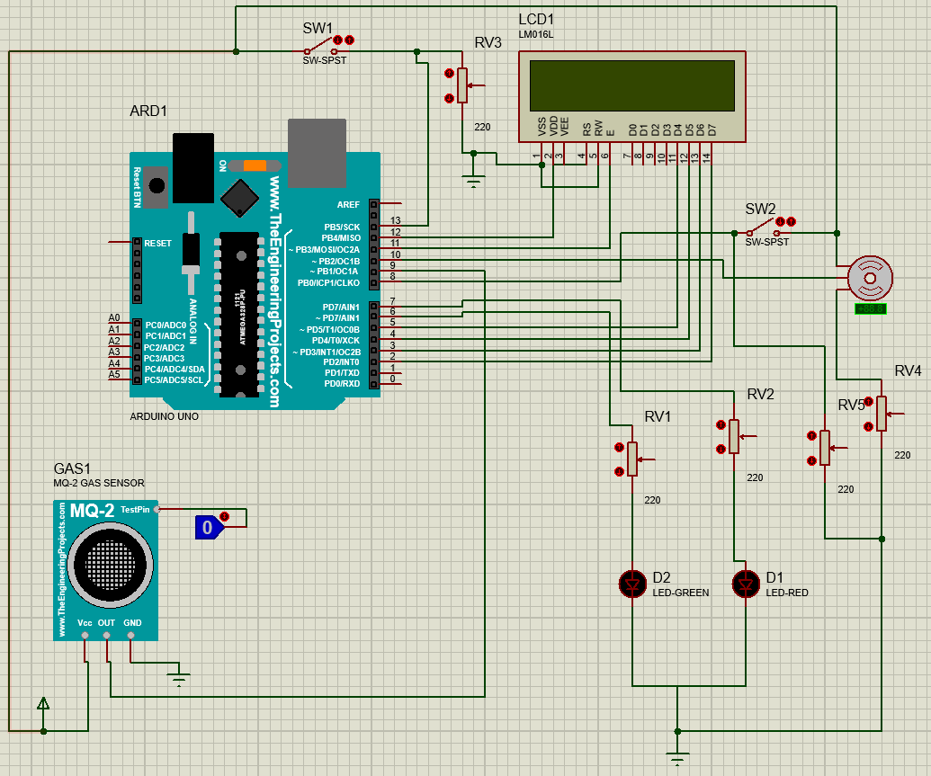

Here, the switch at top middle, is used to turn off and on the whole system. It’s basically the system switch.

Now, at the middle of the circuit diagram, is the Arduino uno R3. Which is the microcontroller board.

At bottom left corner, MQ2 gas sensor with logic Toggle.

At top right corner we see the LCD which will show the current state.

And finally, at the bottom right corner we see the LEDs, RED and green LED.

**Functionality:**

Now, when the system turn off/on switch is on, the smoke detector sensor tries to detect the gas. If the gas is detected then the sensor sends high voltage to pin 9 of Arduino UNO.  
But here, for the simulation purpose we used a logic Toggle to show the system that there is gas.

Which mean if the logic toggle is set to 1 then the smoke sensor act as it found gas and when the logic toggle is set to zero then the smoke sensor act as there is no gas.

So, when there is a signal of detecting gas, then in the LCD display a message “Gas Detected” will be displayed and the red led will turn on. Then the system will force to turn off the gas supply, if it is ON before.

And, when there is No signal of detecting gas, then in the LCD display a message “No Gas Detected” will be displayed and the green led will turn on. Then if the user can turn on the gas supply.

**Code With documentation (comments):**

// The whole code written with proper documentation and with naming convention.

#include<LiquidCrystal.h> // LCD header

#include<Servo.h> // Servo header

void switching_off_the_Gas();//function prototype

void switching_ON_the_Gas();//function prototype

Servo Motor; // motor object

int angle = 1; // motor angle variable

int gasOn ; // switch

int sw; // switch

LiquidCrystal lcd(12 , 11 , 5 , 4 , 3 , 2); // Crystal display setup

int Gas = 9; // gas High/Low comes in

int redLed = 7;

int greenLed = 6;

int gasOnSW = 8; ///// manually off gas On gas switch

void setup() {

Motor.attach(10); // attach the signal pin of servo to pin10 of arduino

pinMode(Gas , INPUT); // gas High/Low

pinMode(13 , INPUT); // system switch

pinMode(gasOnSW , INPUT);// gas on/off switch

pinMode(6 , OUTPUT);//for green LED

pinMode(7 , OUTPUT);//for red LED

}

void loop() {

sw = digitalRead(13); /// system switch

gasOn = digitalRead(8); /// manually off gas On gas switch

if (sw == HIGH) { // system switch On

if (gasOn == LOW && angle != 0 ) { /// manually off the gas

switching_off_the_Gas(); //calling function to turn off the gas

}

if (digitalRead(Gas) == HIGH) { ///if gas detected

lcd.clear();

lcd.setCursor(0, 0);

lcd.print("Gas Detected");

delay(25);

digitalWrite(7 , HIGH); // red led ON

digitalWrite(6, LOW);

delay(25);

if (angle != 0) { // if the gas is not off

switching_off_the_Gas(); // if the gas is not off then colling function to switch off the gas

}

} ///if gas detected

else { ///if not gas detected

lcd.setCursor(0, 0);

lcd.print("No Gas Detected");

delay(20);

digitalWrite(6, HIGH);

digitalWrite(7 , LOW);

if (angle != 90 && gasOn == HIGH ) { // if the gas is off and situation is safe and want to On the gas

switching_ON_the_Gas(); //calling function to switch ON the gas

}

} ///if not gas detected

}

else { // when the system is off

digitalWrite(7 , LOW);

digitalWrite(6, LOW);

lcd.clear();

}

}// end of void loop

void switching_off_the_Gas() {// function to turn off the gas

lcd.clear();

lcd.setCursor(0, 0);

lcd.print("switching off gas");

delay(20);

for (angle = 90; angle >= 0; angle -= 1) // command to move from 90 degrees to 0 degrees

{

Motor.write(angle);

delay(20);

}

angle = 0;

Motor.write(angle);

lcd.clear();

lcd.setCursor(0, 0);

lcd.print("gas off now");

delay(20);

}

void switching_ON_the_Gas() {// function to turn ON the gas

lcd.clear();

lcd.setCursor(0, 0);

lcd.print("switching ON gas");

delay(20);

for (angle = 0; angle <= 90; angle += 1) // command to move from 0 degrees to 90 degrees

{

Motor.write(angle); //command to rotate the servo to the specified angle

delay(20);

}

angle = 90;

Motor.write(angle);

lcd.clear();

lcd.setCursor(0, 0);

lcd.print("gas ON now");

delay(15);

}

**Conclusion:**

This project is just about the simulation of a smoke detecting sensor (MQ2).

But we tried to do much better than it.

But we had to make it simple because of the Platform and system limitations.